Pawfect Match - Phase 2

# Rules

* Submit a Google Doc, NOT a PDF or a Google slide.
* Use the default fonts, line spacing, and font size unless specifically required in the assignment.
* After submission, the Google Doc will get automatically locked, so you won't be able to make any changes.
* Standard plagiarism rules apply.
* Your submission will not be considered for grading and feedback if you do not follow these guidelines.

**Names of Group Members: Riya Sachdeva**

**Rohak Kansal**

**Rohan Beriwal**

**Rohan Devgon**

**Rohan Indora**

**Project Group Number: 3**

**HCI Group No.: 6**

## Requirement Gathering

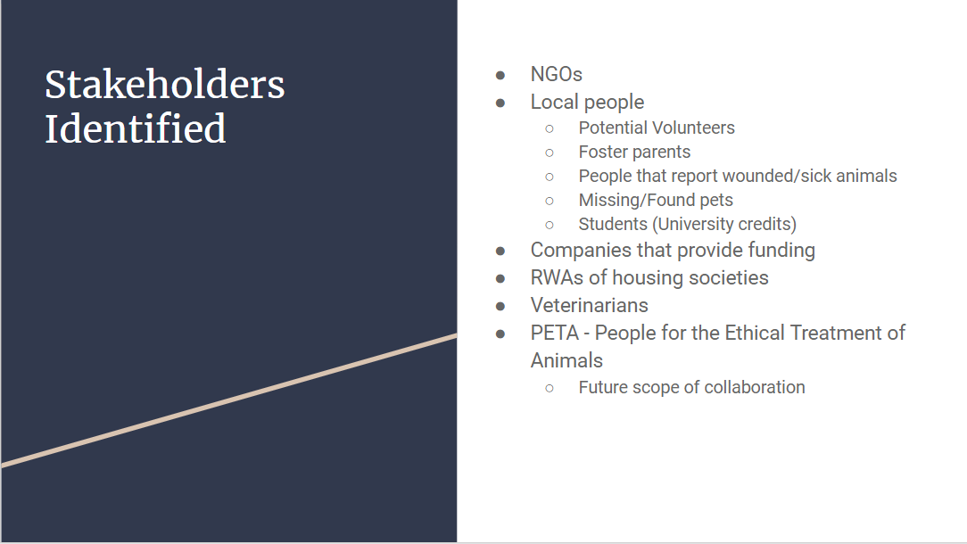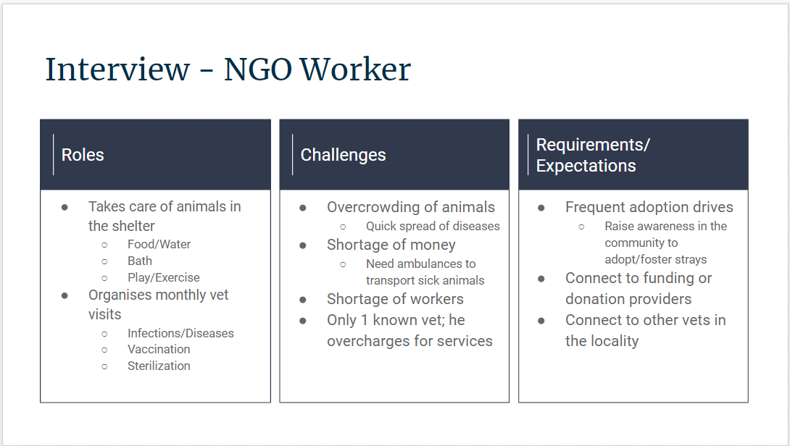

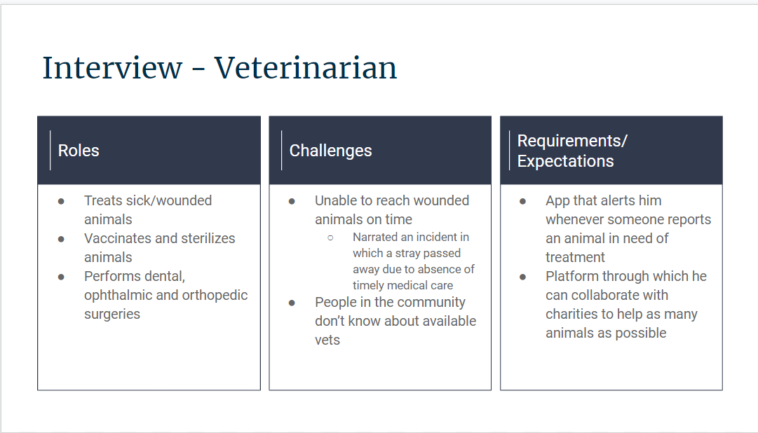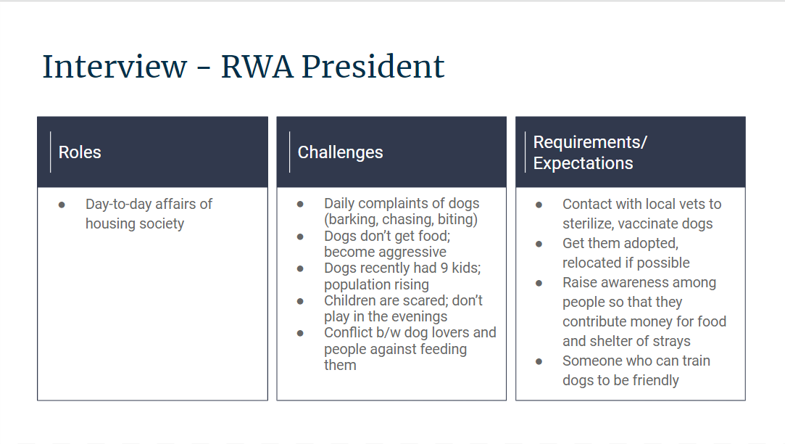

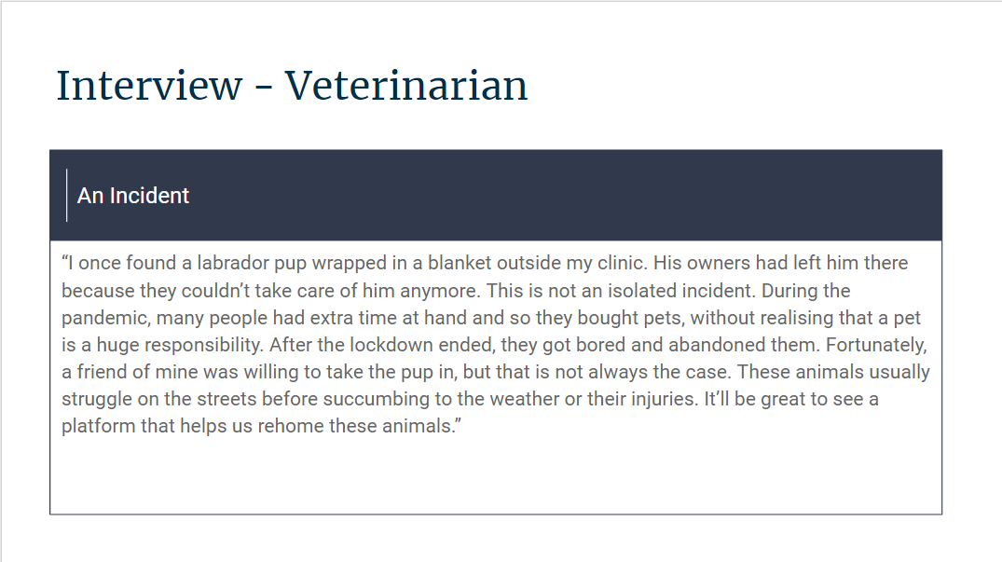

## Use Case Diagram

## 

## Empathy Map: [Quick Retrospective, Online Whiteboard for Visual Collaboration (miro.com)](https://miro.com/app/board/uXjVP3YRO74=/)

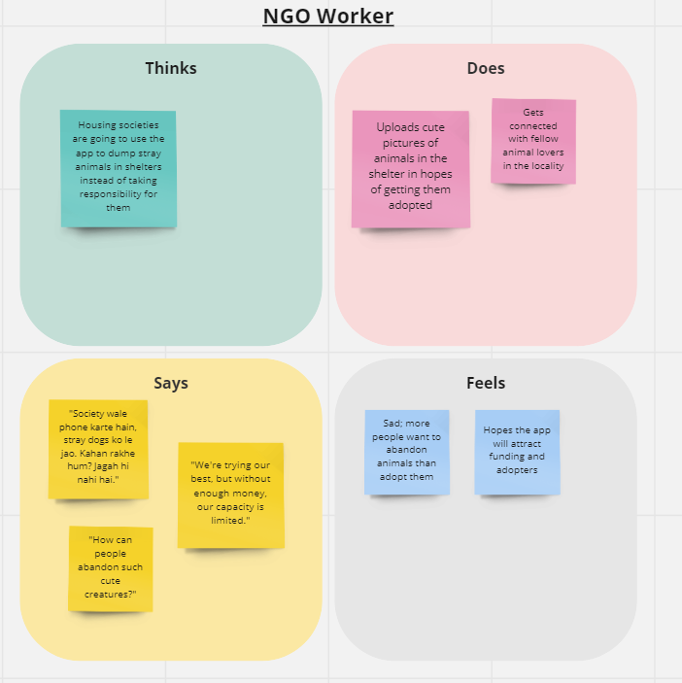

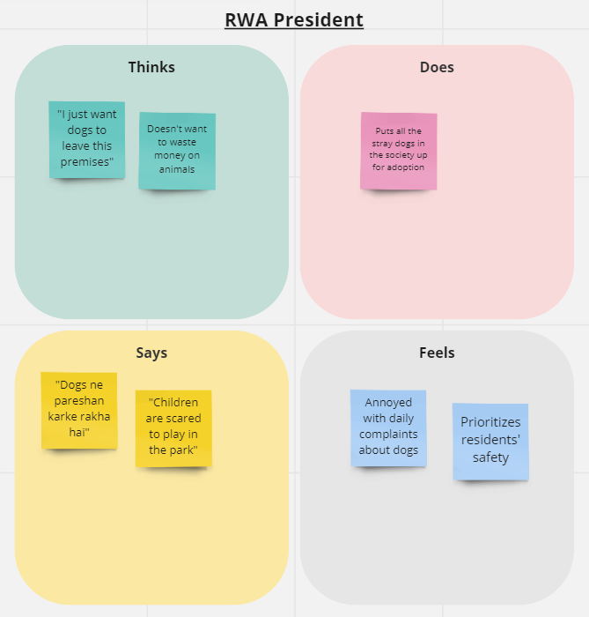

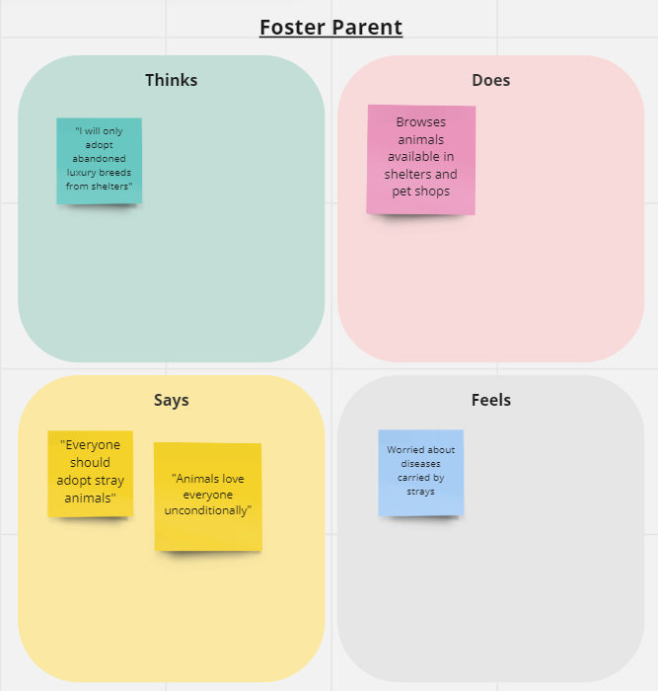

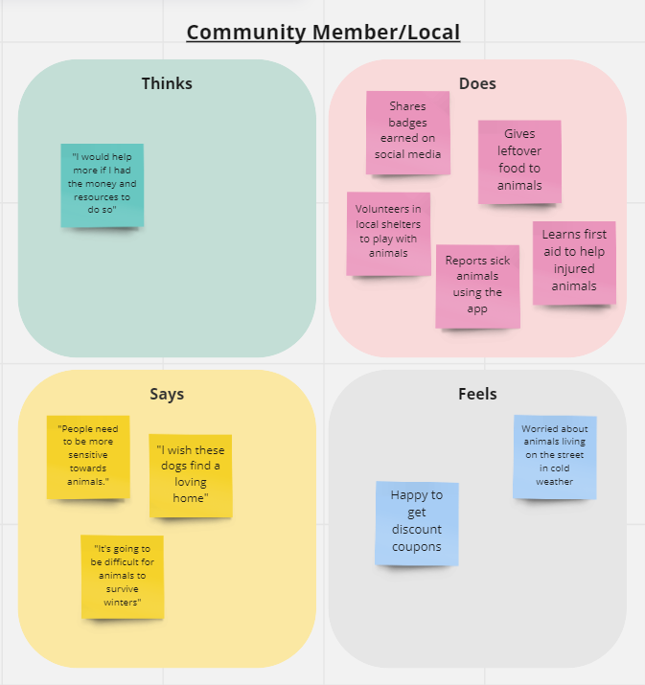

## Personas and Scenarios

## 

## 

## 

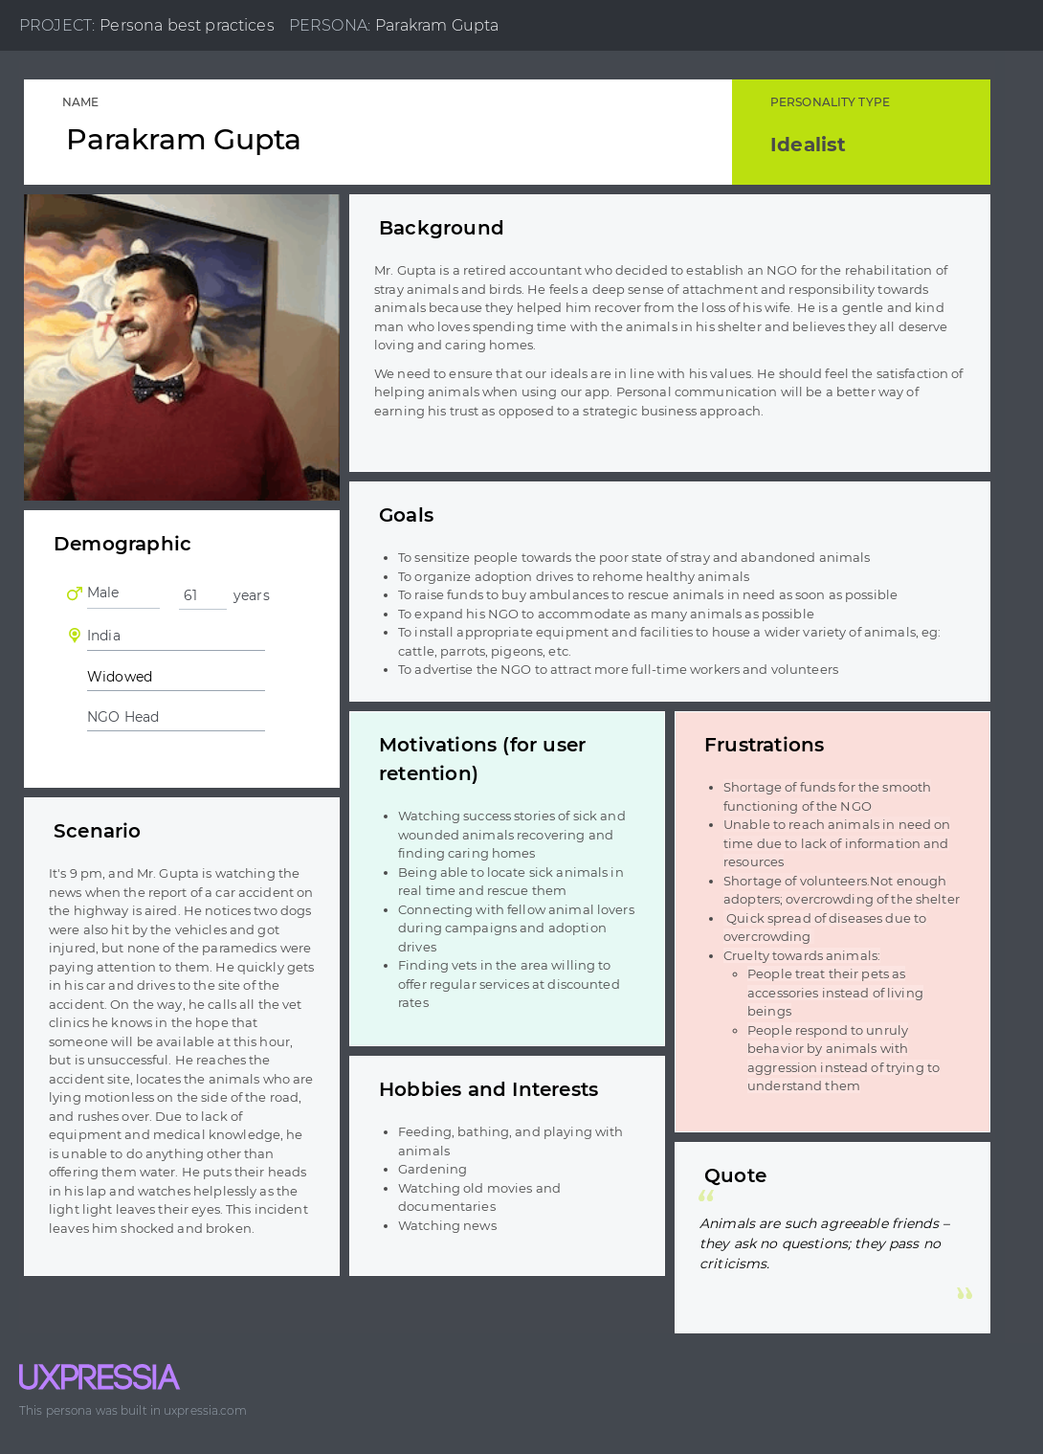

## 

## 

## 

## 

## 

## 

## 

## 

## 

## 

## 

## 

## 

## 

## 

## 

## 

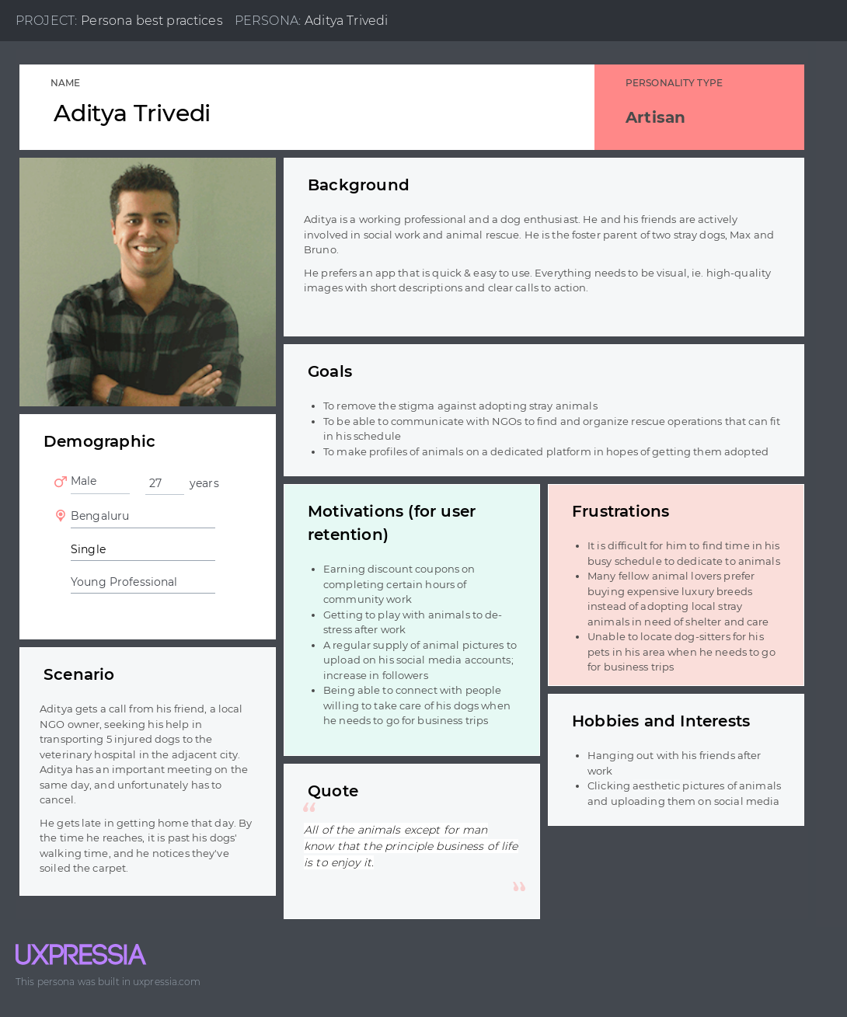

## Problem Understanding

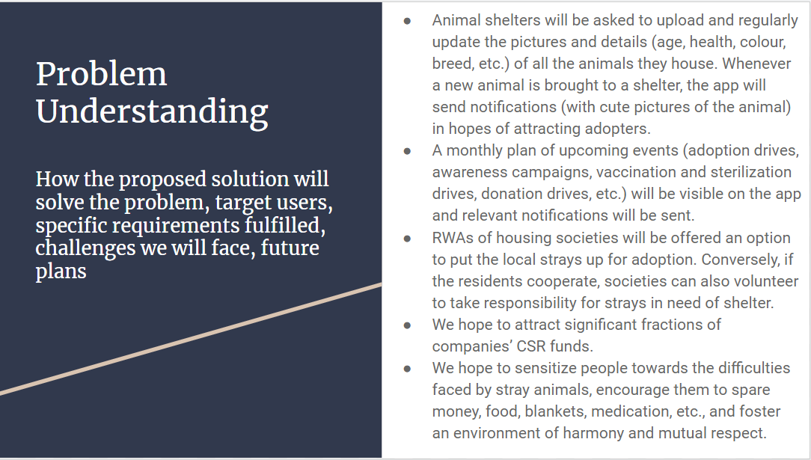

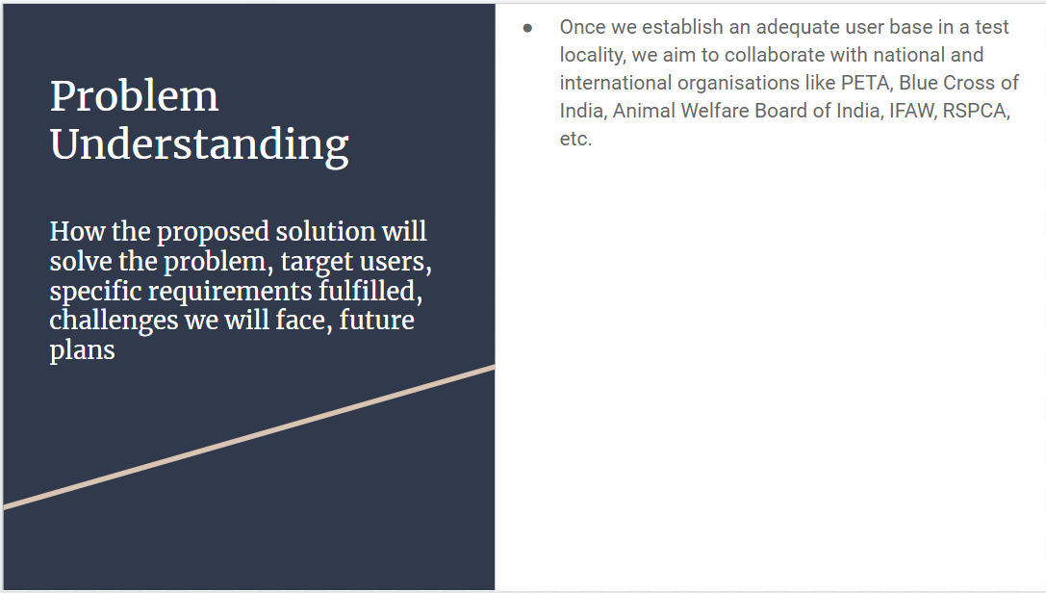

## Low-Fidelity Design

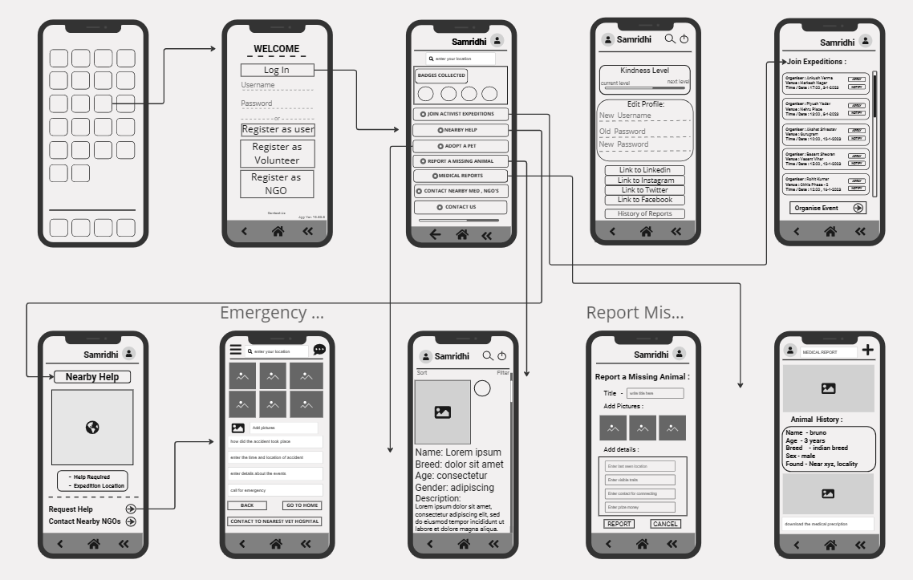

## Low-Fidelity Testing and Testing Methodology

### Testing Methodology:

* In-person Interviews
* Google Form: <https://docs.google.com/forms/d/e/1FAIpQLSf5N7D--IJxOFwBOUJqBEMarSuNx8L3RI6tbvNWb1kkwACE8Q/viewform?usp=sf_link>

### Major Findings:

* The app looks cluttered.
* Reduce the number of features on a given page.
* The concept of “Kindness Level” is rude. I don’t want my app to tell me I’m not kind.
* The font is looks unfriendly.
* Color scheme: White and Blue

## Alternate Design

[App Wireframe, Online Whiteboard for Visual Collaboration (miro.com)](https://miro.com/app/board/uXjVP2f4W4E=/)

(Some icons have disappeared due to zooming out)

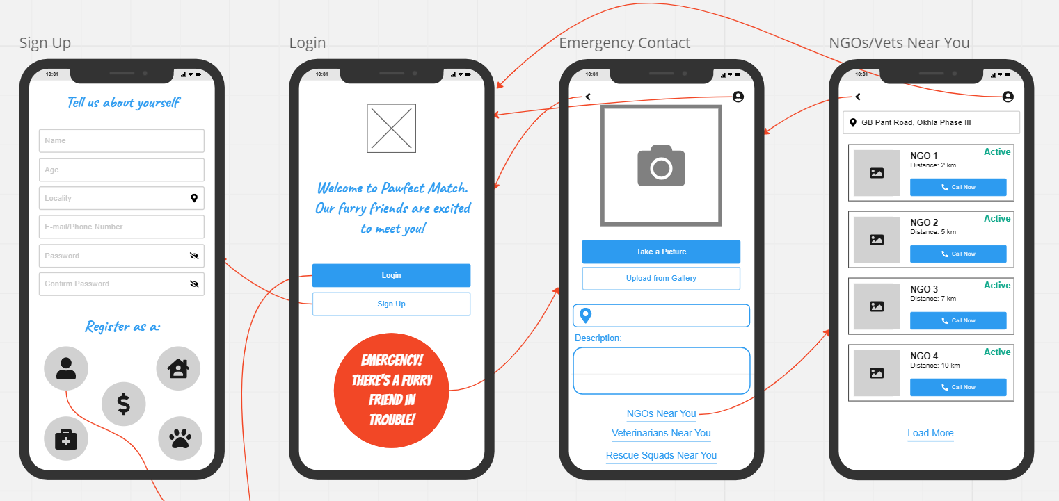

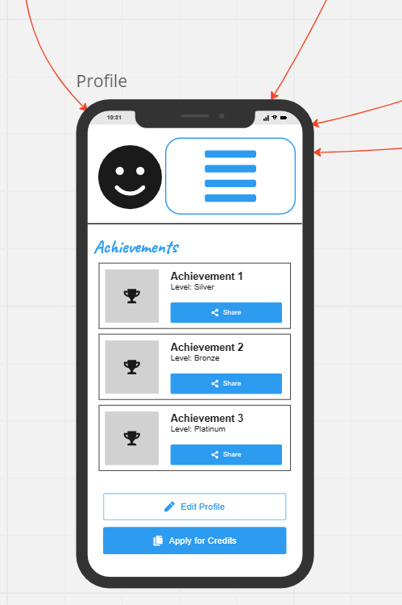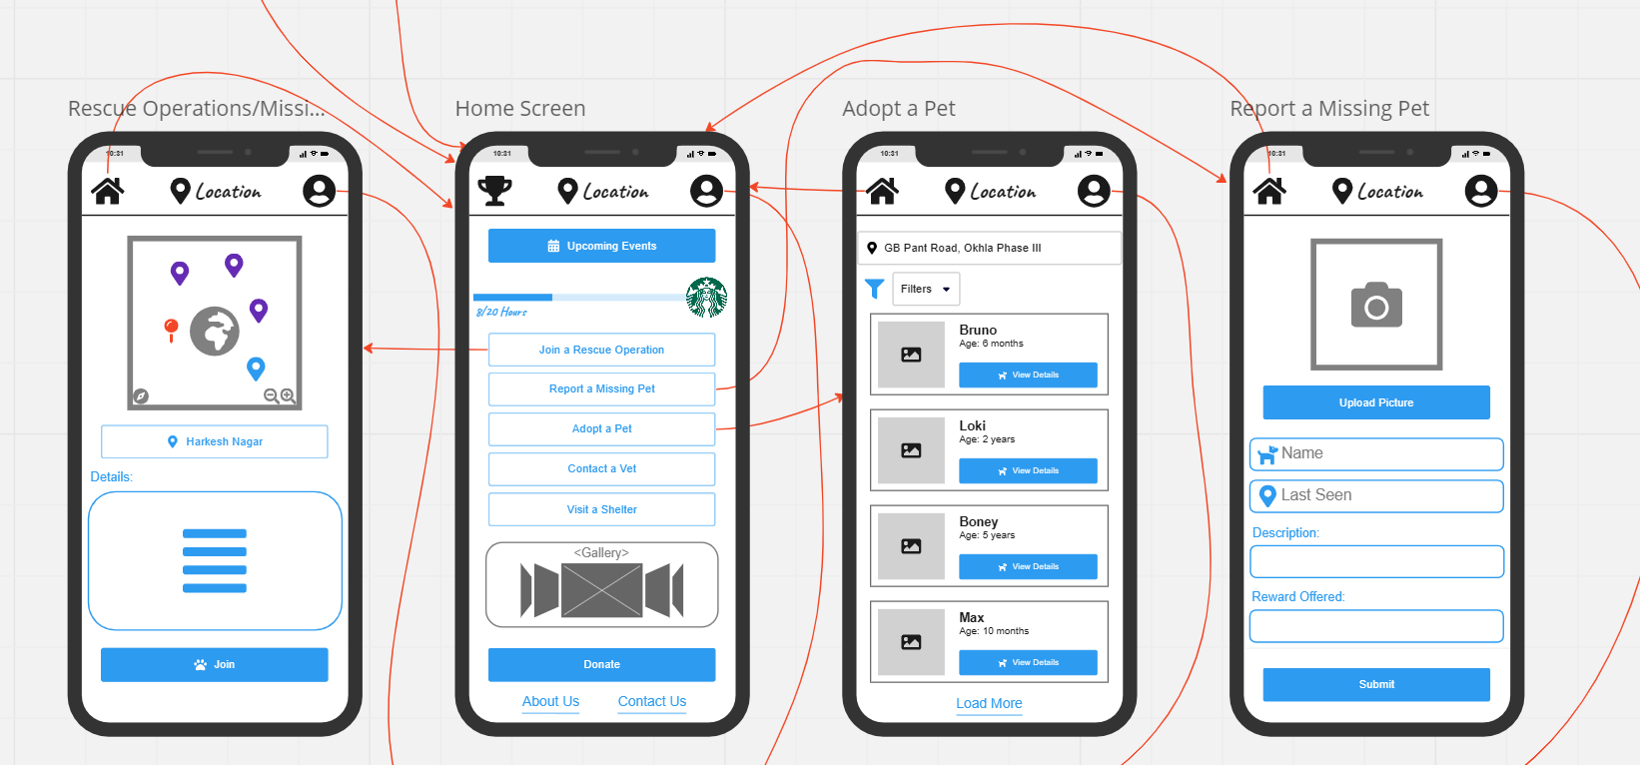

## Contributions

Lo-Fi Design, Alternate Design - Rohak Kansal, Rohan Beriwal, Rohan Devgon, Rohan Indora

Refinement of Requirement Gathering, Personas, Problem Understanding, Lo-Fi Testing, Alternate Design - Riya Sachdeva